**Task 7:Creating Views**

* **View:** A view in SQL is a virtual table that is created using a SELECT query.
* It does not store data physically like a table; instead, it displays data stored in one or more tables.
* You can think of it as a saved query that you can use like a table.
* Views are mainly used for data abstraction, security, and reusability.
* **Examples(Working on Employee table):**

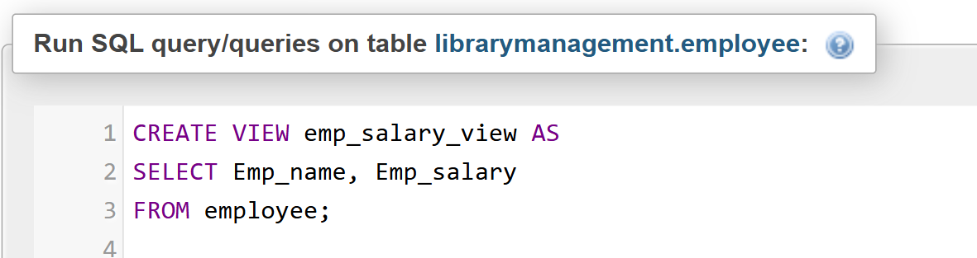

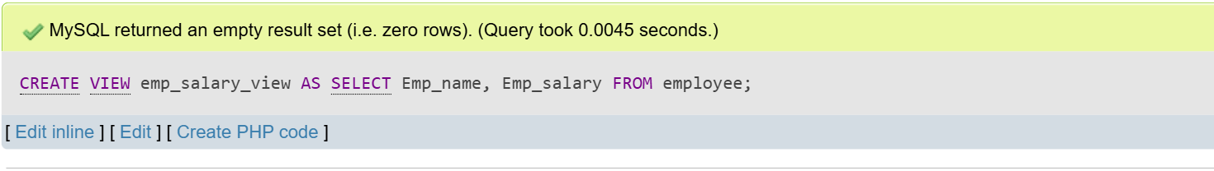**Output:**



**Output:**

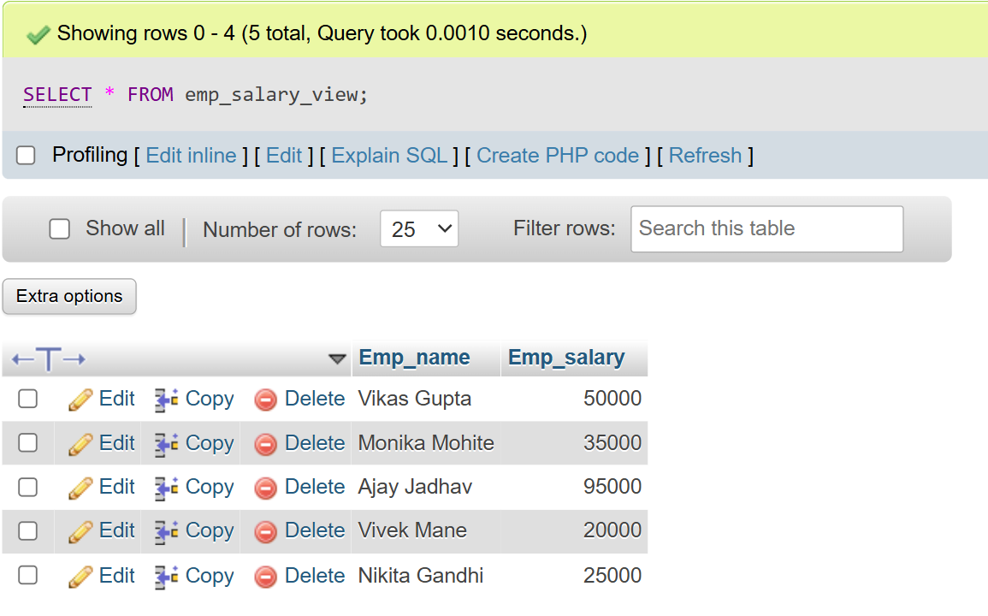

**ii)** 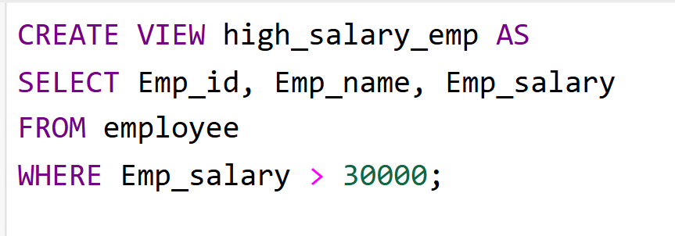

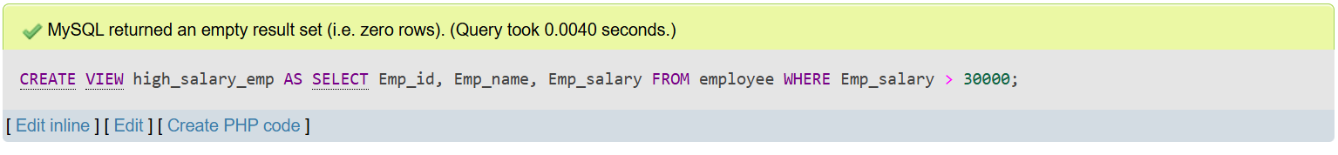**Output:**



**Output:** 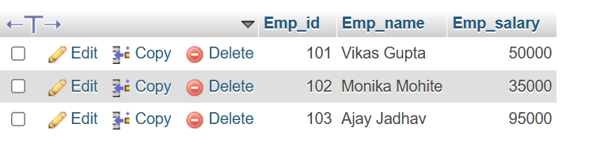

**iii)** 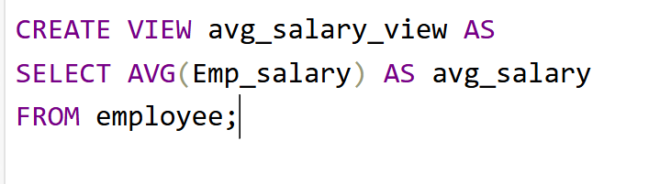

**Output:**

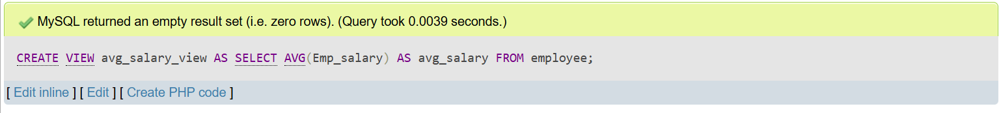



**Output:**

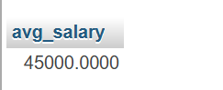

**iv)** 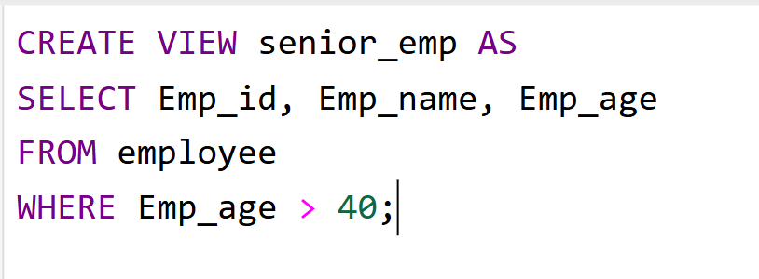

**Output:**

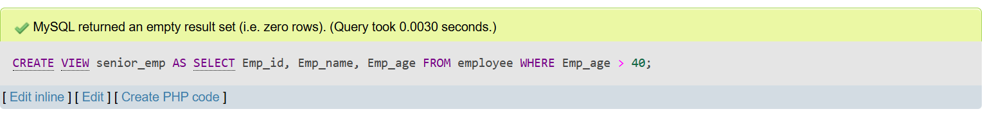



**Output:**

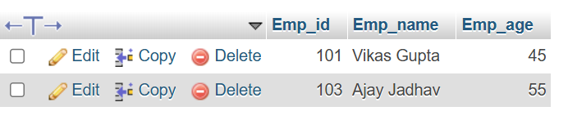

**v)**

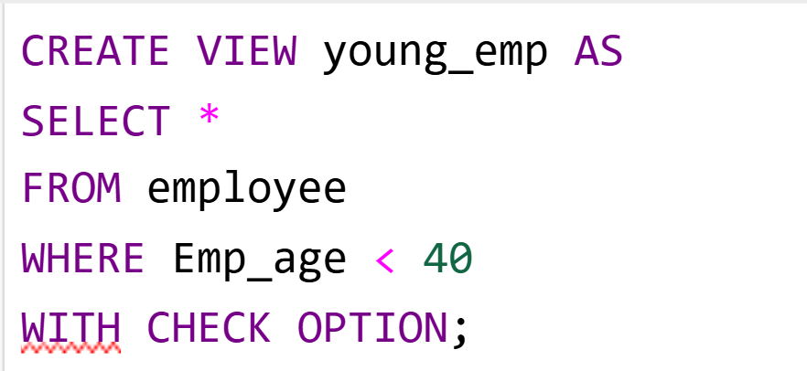

**Output:** 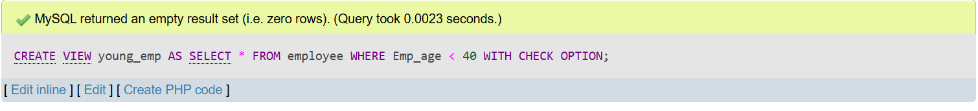



**Output:**

